Differential Equation Ch3-5

This chapter mainly about how to set the Y(t)

Note that in notes:

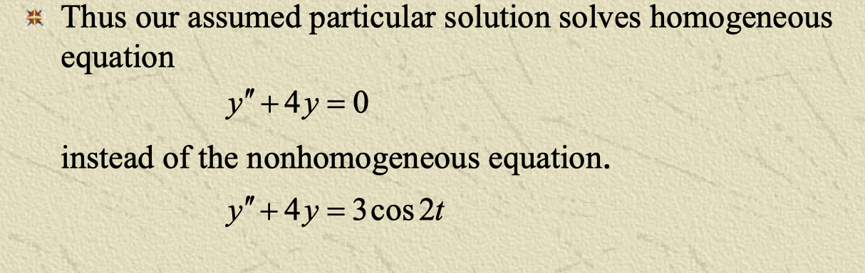

this the characteristic equation for y’’+4y = 0 is r^2+4 = 0, not r^2 + 4r = 0!!